13th April 2016

**Exclusive interview with FIA WTCC 2012 World Champion - the experienced Honda Racing Driver Rob Huff, speaks to David Oliva, YOKOHAMA Europe Communications Manager, on his hopes and aspirations for the new season which took off to a flying start with a victory at the opening round of the new season at the Paul Ricard circuit. ”Huffy” for his friends also gives an insight into professional Motorsports and some tips for young people dreaming of entering the demanding sport.**

**Q. What is your feeling after your first victory after a relatively long time?**

Winning always feels great and to do it on my debut as a Honda factory driver is very special. To win a race at World Championship level is an incredibly difficult thing to do as the level of the drivers and teams around us is so high. I’ve now won WTCC races in four different makes of car, which is also something not many people can say.

**Q. How did you celebrate after winning a race at Paul Ricard?**

I didn’t do much actually. The structure of the day meant that after the podium there were media interviews to do, a debrief ahead of the main race and an autograph session, and then we were into the main race and everything that goes with that. After the race I went to the Nurburgring to drive a car there, so there really wasn’t any time for a big celebration, but you could feel how much it mean to the team to see all their hard work rewarded. My Mum and Dad were at Paul Ricard and they’ve been my biggest supporters since day one, so it was brilliant that they were there.

**Q. It seems you managed to adapt very quickly to a new car, what have been the main difficulties encountered?**

Once you’ve driven a few different kinds of car, you learn how to adapt reasonably quickly. I’ve raced single-seaters and GTs as well as touring cars, and at the end of the day, they all have a steering wheel and some pedals and don’t take that much adapting to. JAS Motorsport, which runs Castrol Honda WTCC, has had a pretty major overhaul of the technical structure during the closed-season, with Duncan Laycock - my race engineer when I won the WTCC in 2012 - joining as the team’s new Technical Director. Because I’m new to the team, I can’t say whether it works better than before, but the fact is that I’ve won a race already and between myself, Tiago and Norbi, we’ve taken four of the possible six podium finishes available over the weekend, so it’s a really good start.

**Q. How is the team spirit at Honda Racing?**

One of the reasons I wanted to join Honda is because JAS are one of the best touring car teams in the world. When things aren’t going so well, the heads never drop, and this is a source of incredible motivation for a driver; you really feel like there’s nothing they wouldn’t do to give you a car in which you can win. What was really notable was when we had an issue costing us straightline speed during qualifying at Paul Ricard, nobody panicked. They were methodical in terms of analysing the data and the feedback I was giving them. The problem was traced to a damaged splitter, which was replaced and sure enough, on race day the car was perfect.

**Q. What is your target for the 2016 season?**

To finish in the top three of the championship, and I think that’s a very realistic target for at least one of the Honda drivers. The championship would be a dream come true, but we have to be realistic and if you look at where Honda were at the end of 2015 compared to the position we’re in now, it’s a significant difference and shows what an amazing job has been done over the winter. The pace we showed in France was terrific, but we’re very aware that we’re currently 80kg lighter than the Citroens, and that when the compensation weights are re-calculated before the Hungaroring, the landscape may well change and we’ll have to see where we are at that point and what we can achieve.

**Q. During the pre-season did you have a specific training routine? Gym/ Nutrition/Jogging? If so what was it?**

Some people think that the off-season is quiet for a driver, but they couldn’t be more wrong. I tend to give myself a month off in December from a strict exercise and nutritional regime, but on January 1 it starts again. As the speeds are slower in the WTCC, you don’t need to follow an F1-style routine, but you still need to be physically fit. My training programme is a mix of boxing, HIIT (High-intensity interval training) and cycling. I don’t do much running as it can be quite punishing on your knees over a long period of time. It works pretty well for me.

**Q. Is it the car or is it the driver?**

A driver is only as fast as his car. I’ve won 28 races in the WTCC and been a World Champion, so I’m confident in my ability as a driver. I didn’t win a race last year, but I don’t believe that’s because I was driving any worse than before. A well-built, well-set-up car can give a driver a huge amount of confidence, as can the way a team is; how they welcome you in, how they treat you, and that can all add to an increase in your performance, but it’s extremely minor compared to a suspension adjustment or an engine upgrade.

**Q. Outside Motorsports/Driving what other interests do you have?**

I’ve recently had a race simulator installed at home, so I’m currently doing a mix of sim work for my professional racing as well as iRacing for fun. I seem to be pretty good too. My Honda team-mate Norbert Michelisz got his big break through sim racing, but we’ve not got around to challenging each other to a race yet. I love playing golf and currently have a handicap of 12 – although I got down to two in 2014. I have three dogs: Snoopie, Minnie and Dolly, who keep me busy; I have business interests in the aftermarket and tuning industry and take my Honda Civic Type-R road car to shows so that I can show it off to people, and I try to socialise and see my friends, which isn’t always easy with a World Championship race schedule, testing, launches and PR commitments.

**Q. What advice would you give young people who are keen in becoming a top professional Motorsports driver?**

Never give up. It can be hard when things aren’t going well, results aren’t going your way, or a backer is considering their future with you, but you just have to keep going and never lose confidence that success is just around the corner. It’s nice to see some very good guys coming in at an older age now – late 20s or even older – so it’s proof that for some, the slog is worth it. Also, you never know who you might meet on your way up the ladder, who they know and how much they might be able to help you in your career, so you need to be nice to people, but still stay genuine with it.

**Q. What do you think of YOKOHAMA Tyres?**

The current Yokohama rubber, which was introduced when the TC2 World Touring Cars came in for 2014, requires an experienced driver to get the most out of it, and I think this probably benefits some of us guys who have been around the WTCC for 10 years or more. You can lean on the rubber ever so hard in qualifying and extract the maximum performance over a single lap. When you’ve put in a storming qualifying lap, that feeling is really quite something. The tyres also promote great racing because if, as a driver, you can learn how to manage the wear well, you put yourself in a very strong position towards the end of a race to attempt a pass on someone who perhaps hasn’t done such a good job.

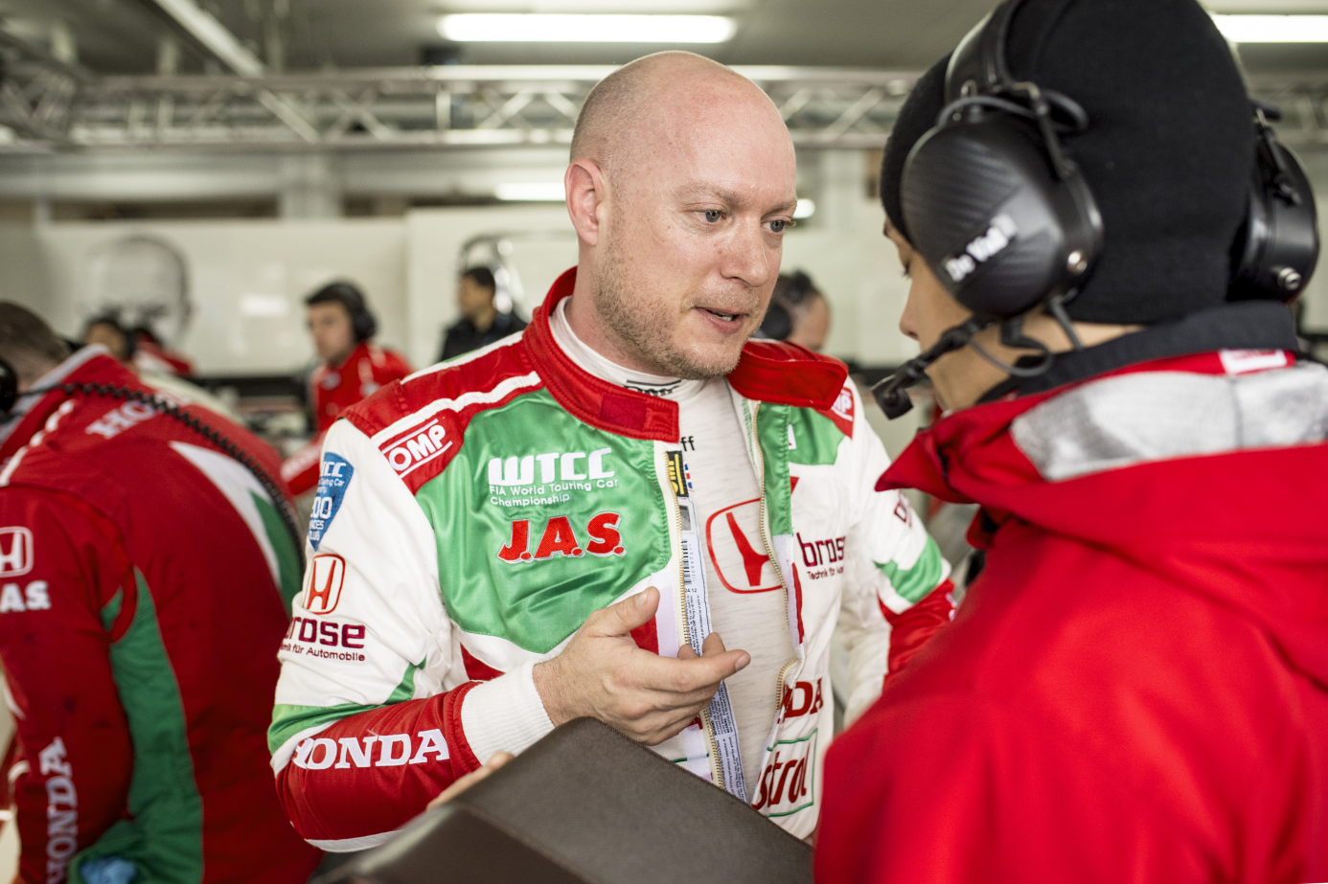

*Huffy consults with Team - Photo V. Curutchet*

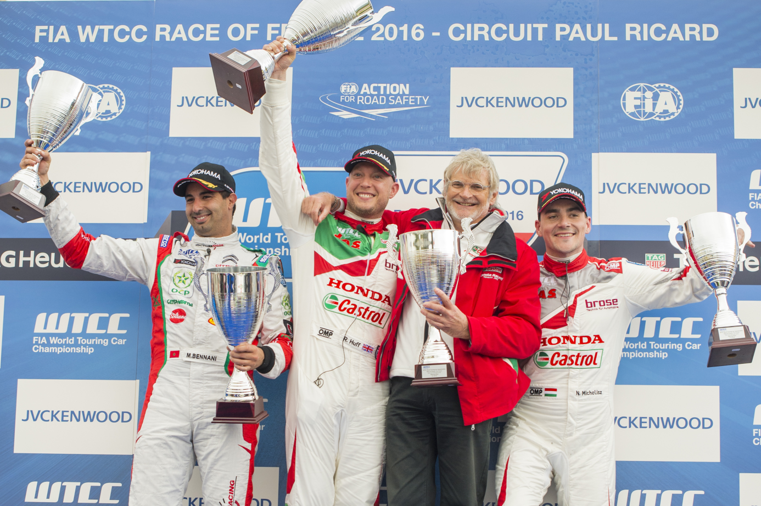

*Rob Huff celebrates race victory in FIA WTCC France - Photo V.Curutchet*

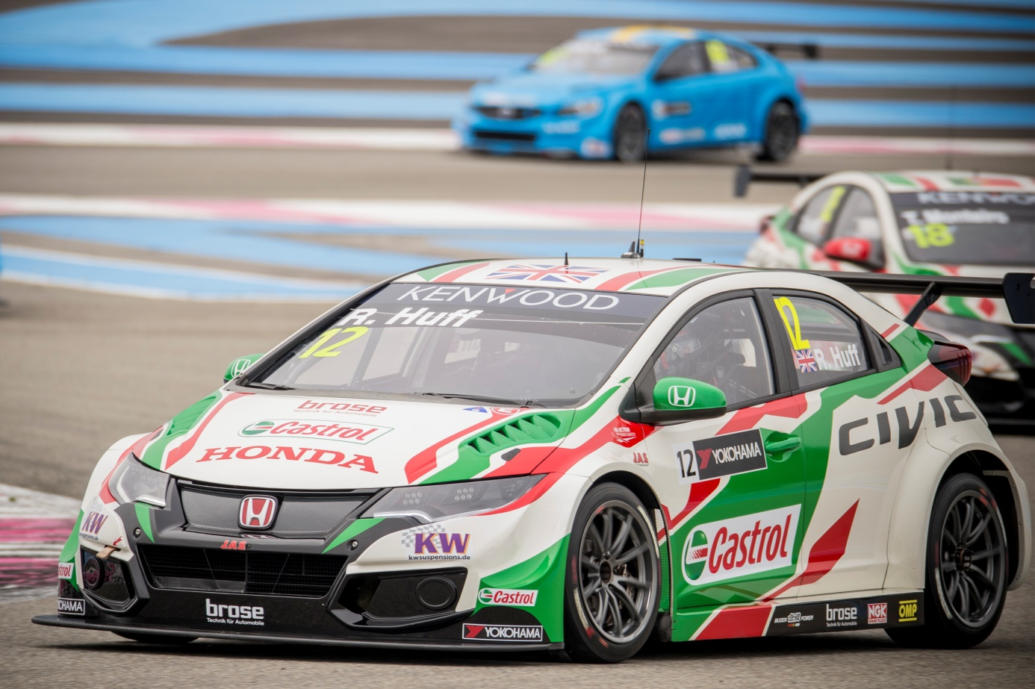

*Honda Racing car driven by Rob Huff - Photo V.Curutchet*